**Name: Deepthi Thalagundamatada**

**Student email ID: dt7637@uncw.edu**

**CSC515: Artificial** **Intelligence**

**Project Report: K nearest neighbor**

**Project:**

**Construct and demonstrate a nearest neighbor classifier for data of your own design or choosing.**

**KNN Algorithm:**

KNN classifies the unseen data through the similarity measure of k- nearest features which are training data set. The similarity is measured using the Euclidean distance.

Advantage: k-NN (where k > 1) is that the probability of misclassifying a sample is reduced because more examples can weigh in on the result.

Disadvantage: The k portion can be taken too far, and if the k value is too large, it can also result in misclassiﬁcation. The value of k should therefore be small, but not too large.

**INPUTS:**

I have taken set of data which is split into the training set and determining sets

**I sample data I have prepare is from the Animal classification where if they have certain features they have been given one otherwise 0.**

Features I used to classify animals are:

hair,feathers,eggs,milk,airborne,aquatic,predator,toothed,backbone,breathes,venomous,**typeofanimal**

**Features from training set are treated as the main sets to which the test set have to be classified.**

**Type of animals I classified are : AQUA, Animals, Birds**

**Example of data set:**

|  |  |  |  |  |  |  |  |  |  |  |  |
| --- | --- | --- | --- | --- | --- | --- | --- | --- | --- | --- | --- |
| hair | feathers | eggs | milk | airborne | aquatic | predator | toothed | backbone | breathes | venomous | typeofanimal |
| 0 | 0 | 1 | 0 | 0 | 1 | 1 | 0 | 0 | 0 | 0 | aqua |
| 0 | 1 | 1 | 0 | 1 | 0 | 1 | 0 | 1 | 1 | 0 | bird |
| 1 | 0 | 0 | 1 | 0 | 0 | 0 | 1 | 1 | 1 | 0 | animal |
|  |  |  |  |  |  |  |  |  |  |  |  |

**IMPLEMENTATION:**

**STEP1:** I am dividing this set in random manner to training set and test set

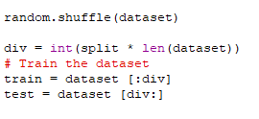

**Step 2:** using Euclidean distance to calculate the distance and nearest set to classify it.

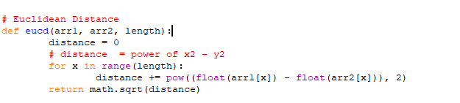

**Step 3:**  Find neighbor

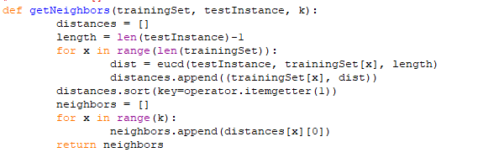

**Step 4:** Classify to the nearest neighbor

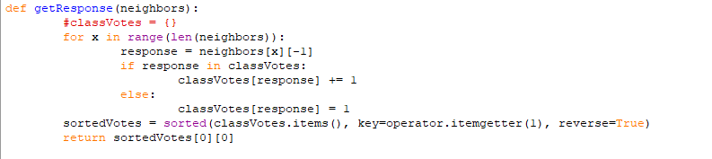

**Results: Sample Results**

